[Egyptian Informatics Journal 23 (2022) 159–172](https://doi.org/10.1016/j.eij.2021.10.002)

Contents lists available at [ScienceDirect](http://www.sciencedirect.com/science/journal/11108665)

Egyptian Informatics Journal

journal homepage: [www.sciencedirect.com](http://www.sciencedirect.com/)

[](http://crossmark.crossref.org/dialog/?doi=10.1016/j.eij.2021.10.002&domain=pdf)An improved Image Interpolation technique using OLA e-spline

Jagyanseni Panda a,⇑, Sukadev Meher b

a *Dept. of Electronics and Communication Engineering, National Institute of Technology Rourkela, (Study leave from SOA University), Rourkela 769008, Odisha, India*

b *Dept. of Electronics and Communication Engineering, National Institute of Technology Rourkela, Rourkela 769008, Odisha, India*

a r t i c l e i n f o

*Article history:*

Received 16 April 2021

Revised 29 August 2021

Accepted 22 October 2021

Available online 19 November 2021

*Keywords:* Artifacts Blurred image Edge expansion Image upscaling

Unsharp masking

a b s t r a c t

Image upscaling aims to increase the resolution and size of a low resolution (LR) image in order to gen- erate a high resolution (HR) image of high frequency (HF). There are several polynomial methods for obtaining a sharpened, upscaled HR image. The interpolated pixel is measured using a weighted average of the neighboring pixels within the image grid that blur at HF regions in these methods. Edge degrada- tion is also caused by other edge-directed and learning-based upscaling methods, which produce blurring artifacts. A novel approach is proposed to fill these gaps. Using the concept of unsharp masking (USM), the LR image is blurred adaptively based on the region’s local variance. The sharpened high pass filtered (HPF) image is then obtained by subtracting the adaptively blurred image from the LR image. According to USM, the HPF image is combined with the LR image via a gain factor optimized using the cuckoo search (CS) algorithm. To compensate for the loss caused by upscaling, this pre-processing step is performed prior to interpolation. Aside from that, the edge of the B-spline interpolated image is detected and expanded. Edge expansion of the upscaled image is performed to further restore the HF details and reduce zigzag artifacts introduced by upscaling while also preserving the edge boundary. The proposed method outperforms the Lanczos, Bicubic, and Bilinear schemes in terms of peak signal to noise ratio (PSNR) gain of 3.475, 8.3839, and 8.075 dB, respectively. In terms of performance, this method outper- forms state-of-the-art techniques both objectively (PSNR and SSIM) and subjectively (visual quality).

© 2022 THE AUTHORS. Published by Elsevier B.V. on behalf of Faculty of Computers and Information,

Cairo University. This is an open access article under the CC BY license ([http://creativecommons.org/](http://creativecommons.org/licenses/by/4.0/)

[licenses/by/4.0/](http://creativecommons.org/licenses/by/4.0/)).

1. Introduction

Images and videos play an important role in multimedia com- munication, which is an important part of the digital world. How- ever, the scarcity of bandwidth poses a problem in the transmission of images and videos via multimedia communication. Narrow bandwidth is ineffective for transferring large amounts of data in image and video communication. To address this issue, the current practice is to scale down the image or video size at the encoder’s end and upscale the received, downscaled image at the decoder’s end. However, a significant loss of image quality

* Corresponding author.

*E-mail addresses:* [jagyansenipanda12@gmail.com](mailto:jagyansenipanda12@gmail.com) (J. Panda), [smeher@nitrkl.ac.in](mailto:smeher@nitrkl.ac.in) (S. Meher).

Peer review under responsibility of Faculty of Computers and Information, Cairo University.

**Production and hosting by Elsevier**

occurs during this process. A low-quality camera lens is another factor that affects image quality. The current paper proposes a method for retrieving the original image’s details and restoring them in the upscaled image. As a result, the final result is a high resolution (HR) image with discrete boundaries and rich texture details, as well as high frequency (HF) region details. HR images have sharpened edges and a richness in texture details. To be more specific, both the object and the background are distinguishable in an HR image, with no blurs. It also lacks ringing artifacts in the image’s HF regions. HR images are currently finding widespread use in medical imaging, satellite imaging, security services (face recognition), and video surveillance systems such as drones are all possibilities. Image upscaling is a difficult process. To begin, the object’s and background’s distinct boundaries must be pre- served while the image’s edge sharpness and texture richness are enhanced. Second, in order to perform image applications in real- time, the upscaling method should be fast and easy. Image upscal- ing is also known as image interpolation, zooming, or enlargement. This paper proposes a new image interpolation technique for producing an HR image. The following are the major contributions

of the proposed work:

<https://doi.org/10.1016/j.eij.2021.10.002>

1110-8665/© 2022 THE AUTHORS. Published by Elsevier B.V. on behalf of Faculty of Computers and Information, Cairo University. This is an open access article under the CC BY license (<http://creativecommons.org/licenses/by/4.0/>).

* The smooth areas and the image’s edges or HF regions are trea- ted differently in this pre-processing step. It is also used prior to

up-sampling to eliminate the artifacts introduced by interpolation.

* A Local adaptive (LA) filter is used to blur the image adaptively

based on the local variance. The filtered image retains the out-

line and smooth-area texture of the original LR image. It is used to highlight the HF of an image.

* The difference between the LR and adaptively blurred images is

referred to as the high pass filtered (HPF) image.

* Following filtration, the LR image and HPF images are combined using an optimum scale factor by using the Cuckoo search (CS)

optimization algorithm to obtain a restored LR image, according to the unsharp masking (USM) concept.

* The restored LR image is then upscaled using edge-preserving

spline (e-spline), retaining all of the previously retrieved details.

The e-spline preserves the shape of the edge while avoiding zig- zag artifacts. Our method is simple and adaptable, relying on simple filtering techniques for different image scales.

To produce a final sharpened HR image, this method restores some details of the LR image that are supposed to be lost after interpolation. The analysis of the results shows that the proposed method consistently generates a high-quality image while preserv- ing the information of both edges and texture. Our method is very simple and adaptable, relying on simple filtering techniques for different image scales. This is a pre-processing technique that improves the edges and fine details in the LR image, which would lose these HF components significantly if up-sampled, resulting in high quality in the upscaled HR version of the image. To overcome the blur and zigzag artifacts caused by upscaling, the LR image is further enlarged using B-spline interpolation followed by edge expansion. As a result, the proposed method is referred to as opti- mized local adaptive edge-preserving spline (OLA e-spline). The remainder of the paper is structured as follows. The application, as well as the specialty of the proposed algorithm, are discussed in the first section. Section 2 contains a review of the literature. Section 3 describes the proposed algorithm, while Section 4 pre- sents experimental results. Finally, conclusion is presented in Section 5.

1. Literature review

In real-time applications to increase the resolution of LR images, various conventional interpolation methods like Bilinear [1], Bicu- bic [2], Spline [3], and Lanczos [4] are proposed. These methods are simple because the value of the interpolated pixel is calculated by averaging or taking a convolution sum of the neighboring pixels. While performing image interpolation using these polynomial- based methods, one often gets blurred edges or staircase artifacts in the resultant image. To overcome these problems, improved edge interpolation methods are proposed in [5–8]. New edge direc- ted interpolation (NEDI) [5] is one local adaptive edge directed interpolation. In this method, the covariance of the HR image can be computed by using duality over LR image covariance. And the missing-edge pixels are interpolated through the edge-directed method and non-edge pixels are interpolated with the bilinear method. The method proposed in [6] is an upgraded version of cubic convolution (CC), i.e. it is Directional CC (DCC). Depending on the direction of the missing pixel, the missing pixel will be interpolated in that direction using CC. One new form of the edge-directional method based on linear minimum mean square estimation (LMMSE), is presented in [7]. The missing pixel is inter- polated in two orthogonal directions using the pixel value of its neighbors in these directions. The final interpolated result is

obtained by fusing the two interpolated values by using LMMSE. Because this method performs edge interpolation along the edge rather than across the edge, boundary information is lost. To deter- mine missing pixels in [8] different gaussian kernels with different standard deviation (SD) are applied. Its SD is determined using the interpolation window SD. This interpolated image’s subjective quality is higher than its objective quality. New approaches of edge restoration are introduced in [9,10] where edge error is used to restore the blur artifacts after interpolation. However, when com- pared to other conventional methods, the flexibility of these meth- ods for different scaling factors is less. To further improve the quality of interpolated results, an alternative method is proposed by Giachetti et al. [11] i.e. the Iterative Curvature Based Interpola- tion (ICBI). The missing pixels are interpolated in edge-directions first. Then, the interpolated values are refined by the smoothening of the second-order directional changes keeping the pixel value constant. However, these methods gave rise to a different issue altogether: the interpolation algorithms cause highly smoothened images; thus resulting in the loss of details. Because of the two- pass approach, the computational time in ICBI is longer. So some methods focus on the computation time of the interpolation algo- rithm. One such fast interpolation method is proposed in [12], where the missing pixels are interpolated by using weighted aver- aging of known pixels in the image grid. In this, the distance between known and unknown pixels is used as a weight for inter- polation. The error occurred as a result of the inaccuracy of the weight prediction. To make interpolation algorithms suitable for real-time applications, the regression-based upscaling methods are approached in [13,14]. A changed version of the NEDI, like autoregressive (AR) is proposed in [13], where a moving least- square method is used. It is also a local interpolation technique, where each LR patch is searched for the nearest neighborhood patches and maps the LR patches to another space for generating HR image. Zhang et al. [14] have proposed an improved AR algo- rithm to get better results, both subjectively and objectively.

To reduce the complexity of the above regression methods, an error-based interpolation method is proposed in [15], which uses the error in between the two sampling points in edge-direction, to interpolate the missing pixels. However, all this method cannot generate sharpened up-scaled images. To overcome this issue, the gradient details of an LR image are used in [16,17] while upscaling it. In [16], the missing pixels are interpolated by using the gradient features of the local, neighboring pixels, for proper reconstruction of the HR image. Similarly, the interpolation method proposed in

[17] uses the gradient sharpening transformation method to get an HR image. However, these gradient-based upscaling methods produce false edges in the resultant images. So, to overcome this problem, Zhu et al. have proposed [18] a learning-based method. It utilizes the geometric structural similarity between the LR patch and the HR patch, alongside using a directional gradient as a regu- larizing factor, to improve the quality of restoration. Zhang et al. have used multiple-linear mapping in [19] that directly maps an LR patch to multiple HR patches. In, [20] variable no. of training patches are used for HR image reconstruction instead of fixed patches. Overall, two drawbacks are noted in these learning- based methods. First, it has a longer running time. Second, its image enlargement works for particular-scale factors only. If the scaling factor changes, the learning method generates artifacts in the texture region and the dictionary-learning methods are very complex. There are some reconstruction-based methods, as dis- cussed in [21,22]. Reconstruction involves the utilization of gradi- ent information from different images a prior, to produce a sharper HR image [21]. Similarly, in [22] the total variation and gradient of the image act as a before reconstruct a sharper image. But as the scaling factor increases, the blurring occurs in the texture part of the image. For this, an HR image looks unnatural. To solve the

issue, Khan et al. [23] have used adjacent pixels slope to generate HR image with texture details. For a complex-textured image, a new reconstruction-based interpolation method is proposed in [24]. But the running time of this method is very high. One new, graph-based interpolation method is proposed in [25] to preserve more detailed information in the HR image. In this method, infor- mation is propagated from a known pixel to an unknown pixel, alongside preserving the information of the sharp edges and con- tinuous texturing. All the above methods fall short of producing sharpened HR images, as they cannot restore the HF degradation happening during interpolation. So, a new method is proposed here, which is based on preserving the edge and texture, to achieve better image quality in interpolation. It also preserves natural looks in the HR image.

1. Problem formulation

The primary goal of image up-sampling is to create a restore HR

the local region variance. This adaptive blurring is used to highlight the image’s HF and deemphasize the image’s smooth region of image. The LA filtered image is then combined with the LR image using a CS optimized scale factor in the following step. The sharp- ened LR image is then interpolated with the B-spline method, fol- lowed by edge expansion. Edge expansion is used to reduce the zigzag artifacts from the interpolated image edge. Finally, as shown in Fig. 2, this method produces a more natural-looking interpolated image.

* 1. *LA filtering*

The LA filtering structure is based on the USM concept. The sharpened image is formed by combining the original image with the HPF image during the USM operation. The LR *GLR* image is extracted from the captured image *GCHR* by deleting the row and column. As illustrated in Fig. 2, the LR image *GLR* is used as an input image. Equ. (1) defines the USM concept as follows:

(*GRHR*) image of various sizes from an LR (*GLR*) image. It refers to the image grid illustrated on the left side of Fig. 1. Let’s assume a 3 × 3

*GSLR*

= *GLR*

+ *kH*(*x*; *y*) (1)

local region of LR image (*GLR*) that zooms by a factor of two. The

image grid is then enlarged and shown on the right side of Fig. 1.

The grid is made up of known pixels (in black) and unknown pixels (white circle). Image interpolation is a technique for determining unknown pixel values using known pixels. The weighted average of neighboring pixels is typically used to predict the missing pixel value, which introduces error. As a result, artifacts such as blurring, ringing, and blocking appear in the interpolated image. This neces- sitates the development of a new interpolation method capable of restoring all edge and texture details in an HR image while avoid- ing artifacts.

1. Proposed Method

As shown in Fig. 2, the proposed technique relies on optimized pre-processing and edge-preserving spline (e-spline). To produce the adaptively blurred image, the LR image is first passed through the LA gaussian filter, whose center pixels are varied according to

ation. (*x*; *y*) represents the pixel coordinate of image. The scaling or gain factor is denoted by *k*. And *H*(*x*; *y*) is the HPF image produced where *GSLR* denotes the sharpened LR image following a USM oper-

by

*H*(*x*; *y*) = *kh*(*x*; *y*) *GLR* (2)

kernel. Convolving *kh* with *GLR* yields the *H*(*x*; *y*). In contrast, *H*(*x*; *y*) where denotes the convolution operation and *kh* is the high pass can be obtained by subtracting the smooth or low pass version of

input from *GLR*. It is also specified as

*H*(*x*; *y*) = *GLR*(*x*; *y*) — *kl*(*x*; *y*) *GLR*(*x*; *y*) (3)

*H*(*x*; *y*) = *GLR*(*x*; *y*) — *HAb*(*x*; *y*) (4)

where *kl*(*x*; *y*) is the low pass kernel and *HAb* is the adaptive blur image obtained with algorithm 1.

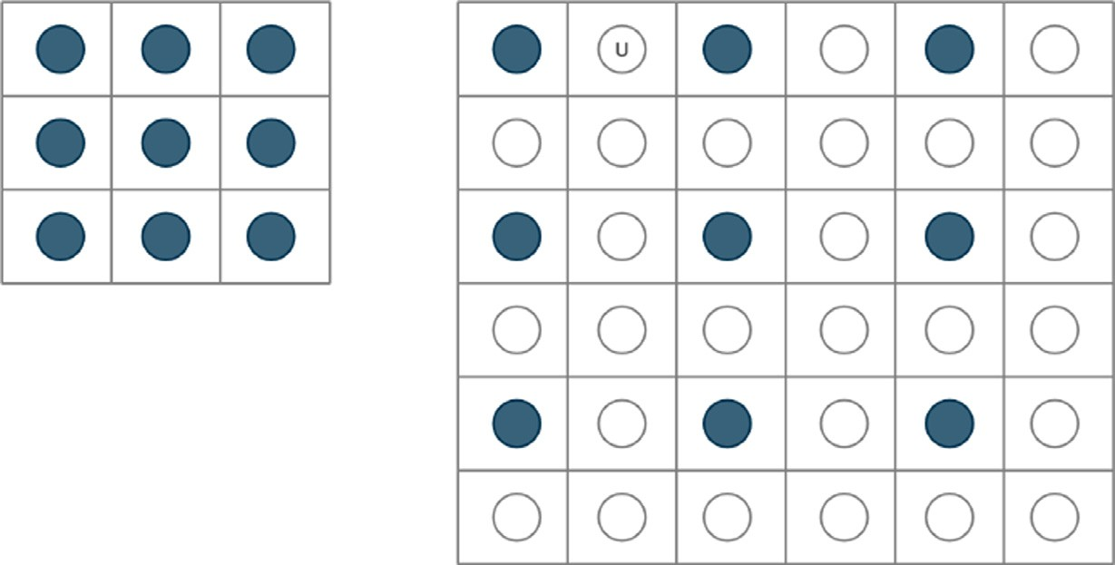

Fig. 1. Image upscaling.





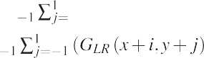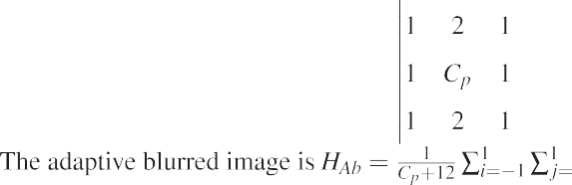

Blur is introduced in interpolation as a result of the incorrect estimation of pixel value at an unknown location. To address this issue, the USM concept [26] is applied prior to up-sampling, result- ing in less blurring after upscaling. The low pass or smoothed ver- sion of the image is extracted using LA gaussian filtering, denoted as *gf* . Over the *GLR* image, the gaussian mask *gf* is applied. The vari-

ance of the local 3 × 3 regions of *GLR* affects the center pixel *Cp*

value of the gaussian masks *gf* . Because our goal is to make high

variance regions or image edges more pronounced. The statistical

variance is highest in the local region containing the image edges. If the local variance is high, the gaussian filter’s center pixel weight will be reduced, resulting in more blurring. As mentioned in algo- rithm 1, the weight of the center pixel is increased if the local region variance is low in order to obtain a less smooth image. Finally, deducts the local adaptive blurred *HAb* image from the *GLR*

and extracts the sharpened HPF *H*(*x*; *y*) image as given in Equ.

(3). The *H*(*x*; *y*) is scaled and added to the *GLR* using a gain factor

*k*. As a result, the sharpened LR image *GSLR* obtained in Equ. (1).

CS algorithm. The gain factor indicates how much of *H*(*x*, *y*) is con- Because the scale factor *k* influences *GSLR*, it is optimized using the tributed for detailed and sharpened *GSLR*. Meta-heuristic optimiza-

tion methods such as particle swarm optimization (PSO) [27], CS [28], and genetic algorithm (GA) [29] are used in single or multiple parameter optimization. Because the CS algorithm requires only one parameter, population, to be initialized at the start of the method, it is used for optimizing the gain *k* factor.

* 1. *CS Optimization*

The CS [30] is inspired by cuckoo species’ obligate brood para- sitism, which involves laying eggs in host bird nests. It is preferred over PSO because PSO [31] demanded that motion inertia and coef- ficients be assumed at the start of the algorithm. If the initial parameter assumption is incorrect, the method is not expected to







converge. When compared to GA [32], CS is much simpler because it does not include mutation, crossover, or selection stages.

Each egg in a nest represents a solution in computer science, and a cuckoo egg represents a new solution. The goal is to use new and potentially better solutions (cuckoos) to replace less- than-ideal solutions in nests. Each nest contains one egg, which represents one solution, or multiple eggs, which represent multiple solutions. The CS is based on three fundamental rules.

* + - Each cuckoo lays one egg at a time and deposits it in a randomly selected nest.
    - The best nests with high quality eggs (solution) will carry over to the next generation.

The host bird can either discard the egg or abandon the nest to build a new nest in a different location. The characteristic equation is as follows:

*c*(*t* + 1) = *c*(*t*) + *s*.*l*(b) (5)

where *c*(*t*) represents the current position. The next position is rep- resented by the *c*(*t* + 1). *l*(b) is derived from the Levy distribution, where Levy flight represents the probability of a transition. The *s*

represents the step size. The scale factor required to optimize is encoded in the cuckoo egg in CS. In this, is only one gain factor *k*

is to optimize. There are *n* nests in the CS, i.e.*xi*, *i* = 1, 2, 3, ..., *n*.

The nest is initially assigned a random position within the solution

space. Then, at random, select a cuckoo from a specific nest and replace its solutions with the Levy flight algorithm described in algorithm 2. The best nest or solution is then chosen based on the fitness function and moved towards the optimal solution according

to generation *t* = 1, 2, 3, .. . , *g*.

* 1. *Levy flight*

In between consecutive jumps, Levy flight takes a random walk. In Equ. (5), a power law step length with Mantegna’s distribution is used to generate random steps given.

# *l*(b) = *t*—b, 1 < b < 3

The distance covered in a fixed number of iterations is deter-

mined by the step length b. If b is too small, the new solution will be trivial, and if b is too large, the solution will be out of the search space. The step size *s* is represented as

1

* + - The number of host nests is fixed, and a host has a chance of dis- covering an alien egg with probability *p* ∈ [0, 1].

*s* = 0.01 *

*mi* b

## *ni*

where *m* and *n* are normally distributed variables i.e. *mi* = *N* 0, r2 and *ni* = *N* 0, r2 where r*m* and r*n* are defined as

*m*

*n*

0*sin* p*b .C(1 + b)1

2

Table 1

3 × 3 matrix taken from interpolated image.

E(x-1, y-1) E(x-1, y) E(x-1, y + 1)

E(x, y-1) E(x, y) E(x, y + 1)

r*m* = @

2

C 1+b

b—1 A

and

r*n* = 1

2 .b. 2

E(x + 1, y-1) E(x + 1, y) E(x + 1, y + 1)

*4.5. e-spline algorithm*

* 1. *B-spline interpolation*

Image up-sampling deals with fitting a continuous curve over the discrete point using known information. In the case of image up-sampling, the missing pixels in the image grid are filled up using the known pixel information. For smoothing images, the cubic B-spline [33] up-sampling method outperforms the tradi- tional Bilinear, Bicubic, and Lanczos interpolation methods. A sec- tion of the polynomial curve that passes through the knot represents the cubic B-spline [34], which is a degree 3 polynomial. With the curvature property, the polynomial curve produces a bet- ter prediction of unknown pixel values. As a result, it produces minimal optimum quality up-sampling. Equ. (6) can be used to perform 2D interpolation over a sharpened LR *GSLR* image of size

*M* × *N*.

*M*—1*N*—1

XX

*GHR*(*x*, *y*) = *C*(*i*, *j*)b3(*x* — *i*)b3(*y* — *j*) (6)

*i*=1 *j*=1

where *x*, *y* ∈ *R* and *i*, *j* ∈ *z*. The cubic B-spline coefficient is described by *C*(*i*, *j*). b3(*x*) represents the third order cubic B-spline convolution kernel. b3(*x*) is obtained by convolution of a basic B-spline kernel of degree 0 four times, i.e. b0(*x*). The formulary for calculating b3(*x*) is

interpreted as follows:

Initially, the LR image is expanded using the B-spline interpola- tion technique. The canny edge detection algorithm is then applied to an interpolated image. In the third stage, values will change based on the orientation and detected edge of the neighboring edge pixel, as described in Equ. (11) and (12). Following the com- pletion of the preceding steps, the resulting image is our true edge-

preserving spline, i.e. e-spline image. Let *E*(*x*, *y*) be the edge pixel

detected by the canny edge detector shown in the following

changes at (*x*, *y*) pixel can be expressed as Table 1. According to this, the horizontal and vertical direction

*SDh*(*x*, *y*) = 1 [*E*(*x* — 1, *y* — 1) — *E*(*x* — 1, *y* + 1)]

# 4

1

+ 2 [*E*(*x*, *y* — 1) — *E*(*x*, *y* + 1)]

# 1

+ 4 [*E*(*x* + 1, *y* — 1) — *E*(*x* + 1, *y* + 1)] (9)

*SDv* (*x*, *y*) = 1 [*E*(*x* — 1, *y* — 1) — *E*(*x* + 1, *y* — 1)]

4

# 1

+ 2 [*E*(*x* — 1, *y*) — *E*(*x* + 1, *y*)]

# 1

+ 4 [*E*(*x* — 1, *y* + 1) — *E*(*x* + 1, *y* + 1)] (10)

If |*SDh*(*x*, *y*)| P |*SDv* (*x*, *y*)| then it indicates edge is in the vertical

# b3 =

2 — 1 |*x*|2(2 — |*x*|) 0 6 |*x*| < 1

1 (2 — |*x*|)3 1 6 *x* < 2

>:

6

3

2

8><

0 *otherwise*

# 8> 1 —0.5 6 |*x*| < 0.5

2

b0(*x*) = < 1

|*x*| = 0.5

(8)

:

(7)

direction so change the adjacent pixel values of the edge detected

pixel (*x*, *y*) by

*E*(*x*, *y* — 1) = 1 (*E*(*x*, *y* — 1) + *E*(*x*, *y* — 2)) (11)

# 2

1*E*(*x*, *y* + 1) =  (*E*(*x*, *y* + 1) + *E*(*x*, *y* + 2)) (12)

2

> 0 *otherwise*

Because of the diminishing property [35], this is the smoothest interpolating function. So preserving the edge part of the interpo- lated image motivates us to improve the image’s high variance or edge part. In addition, to remove the zigzag artifacts and obtain a

If |*SDh*(*x*, *y*)| 6 |*SDv* (*x*, *y*)| then it represents the horizontal

changes occurs in image. The adjacent pixels will be changed as

given in

*E*(*x* + 1, *y*) = 1 (*E*(*x* + 1, *y*) + *E*(*x* + 2, *y*)) (13)

# 2

crisper interpolated image, the expansion after interpolation is 1

## *E x*

performed. To detect the edge, a canny edge detection method is

used before an edge-based expansion method. The expansion is

applied after interpolation to reduce artifacts caused by up- sampling such as blurring, zigzag, and blocking. Because the edges are blurred in the non-stationary region of the image, the edge detection operator is critical. The pixel value of the edge pixels changes quickly in nonstationary regions. Because of this, image interpolation is not well approximated, and blur is introduced. It is required for the detection of a true edge from an up-sampled image using a canny-based edge detection technique. The canny edge detector is used for the following facts.

* It will detect a one-pixel wide edge that is close to being a true or real edge.
* When the signal-to-noise ratio is maximized, the possibility of false edge detection is very low.

( — 1, *y*) = 2 (*E*(*x* — 1, *y*) + *E*(*x* — 2, *y*)) (14)

Pixels *E*(*x* + 2, *y*) and *E*(*x* — 2, *y*) are located on the lower and upper sides of pixels *E*(*x* + 1, *y*) and *E*(*x* — 1, *y*), respectively. The pixel between two edge pixels remains unchanged. Following this

edge expansion, the edges of the HR image *Ge* are aggregated with *GHR* to form *GRHR*, and the up-sampled image appears more natural- looking. Several artifacts are being reduced as a result of edge expansion and interpolation.

*GRHR* = *GHR* + *Ge* (15)

1. Experimental Result

Various images from standard image processing, Set 5, and Set 14 are used to evaluate the performance of the proposed method.

Any scaling factor is used to downsample the captured images. In this case, the proposed method is used to upscale the LR image

and recover the HR image from it. The proposed technique can

where *k* and *l* be the local window of size *W* × *W* of up-sampled and captured image. l*k* and l*l* is the average value of local window *k*

and *l*. r2 and r2 is the variance of window *k* and *l*. r*kl* is the local

*k l*

be objectively evaluated using PSNR, structural similarity index (SSIM) [36], and feature structural index measurement (FSIM). Dif- ferent upscaling factors, such as 2 and 4, are used to assess the per- formance of the proposed scheme. PSNR is the signal power divided by the noise power. If its value is high, it indicates that the signal has been restored successfully. The PSNR is calulated by

window covariance. *v*1 and *v*2 is the variable use to stabilize the Equ. (18) when zero appear in denominator.

*v*1 = (*x*1*D*)2 *and v*2 = (*x*2*D*)2

*where the default value of x*1 = 0.01 *and x*2 = 0.03. (19)

where *D* is the dynamic range of image. The performance tables

*PSNR* = 10. *log*

*MAX*

10 *MSE*

# (16)

demonstrate the proposed technique adaptability to different image

sizes. Face, Airplane, and Baby images are considered for subjective evaluation because they belong to high (edge or high variance

where MAX represents the maximum intensity value of pixel of

image and MSE is the mean sqared error and determined by

*M*—1*N*—1

= 1 XX[ *CHR*( , ) — *RHR*( , )] ( )

## *MSE G x y G x y* 2 17

*M* × *N x*=0 *y*=0

The structural similarity between the upscaled image and the

captured image is represented by the SSIM. The SSIM is obtained by using

region), medium (medium variance region), and low (smooth or less variance region) frequency bands. The error image, which is the dif- ference between the interpolated and original images, is used to evaluate the proposed method’s performance. If the error difference is small, it demonstrates better edge and texture restoration; how- ever, if the difference is visible, edge preservation will not occur. Apart from the state-of-the-art algorithms, the proposed method outperforms the Lanczos and other state-of-the-art methods for

various images, as shown in Tables 2 and 3. Table 4 shows the aver-

*SSIM*(*k*, *l*) =

2l l + *v* (2r + *v* )

l2 + l2 + *v*1 r2 + r2 + *v*2 (18)

*k l* 1 *kl* 2

*k l k l*

age PSNR gain of various cutting-edge techniques. The experimental results of the OLA e-spline, as well as existing algorithms, are shown below. Fig. 3 and 4 depict the subjective performances of Baby

(512 × 512) and Face (276 × 276) using algorithms at 1:4 upscaling.

Table 2

PSNR (dB) outcomes of several 1:4 upscaling method

|  |  |  |  |  |  |  |  |  |  |  |
| --- | --- | --- | --- | --- | --- | --- | --- | --- | --- | --- |
| Method Image | Performance Parameter | Bilinear [1] | Bicubic [2] | Lanczos [4] | NEDI [5] | ICBI [15] | DST [9] | Edge error  [10] | USM | Proposed |
| Monkey | PSNR (dB) | 24.4462 | 23.8962 | 29.7933 | 23.0902 | 23.2438 | 23.2841 | 22.5778 | 23.0576 | 30.1449 |
|  | SSIM | 0.5760 | 0.6192 | 0.5708 | 0.5265 | 0.5412 | 0.6384 | 0.5608 | 0.6103 | 0.6471 |
|  | FSIM | 0.9290 | 0.9590 | 0.8704 | 0.9489 | 0.9508 | 0.9517 | 0.9949 | 0.9449 | 0.9991 |
| Airplane | PSNR (dB) | 32.3601 | 31.2664 | 39.6672 | 29.8161 | 30.1243 | 30.2296 | 28.3969 | 29.8647 | 44.8822 |
|  | SSIM | 0.9209 | 0.7483 | 0.8534 | 0.6881 | 0.7025 | 0.9047 | 0.8778 | 0.8964 | 0.9284 |
|  | FSIM | 0.9843 | 0.9625 | 0.9326 | 0.9598 | 0.9611 | 0.9612 | 0.9972 | 0.9596 | 0.9722 |
| House | PSNR (dB) | 32.0809 | 31.5451 | 32.8524 | 30.6702 | 30.5516 | 30.6328 | 29.6852 | 30.4241 | 33.0807 |
|  | SSIM | 0.8508 | 0.5548 | 0.6041 | 0.5119 | 0.5208 | 0.8404 | 0.7949 | 0.8327 | 0.6457 |
|  | FSIM | 0.8933 | 0.8824 | 0.7512 | 0.8848 | 0.8862 | 0.8866 | 0.9749 | 0.8780 | 0.7394 |
| Peppers | PSNR (dB) | 31.7061 | 31.1493 | 37.6293 | 30.4879 | 30.5189 | 30.5594 | 29.4785 | 30.3161 | 38.7196 |
|  | SSIM | 0.7721 | 0.5500 | 0.6739 | 0.5036 | 0.5148 | 0.7852 | 0.7586 | 0.7765 | 0.7977 |
|  | FSIM | 0.9872 | 0.9741 | 0.9387 | 0.9744 | 0.9020 | 0.9750 | 0.9973 | 0.9723 | 0.9191 |
| Lena | PSNR (dB) | 32.8712 | 31.6746 | 35.6507 | 30.6258 | 30.7563 | 30.8307 | 30.5510 | 30.6464 | 39.8594 |
|  | SSIM | 0.8733 | 0.6223 | 0.7349 | 0.5672 | 0.5801 | 0.8634 | 0.8301 | 0.8551 | 0.8870 |
|  | FSIM | 0.9876 | 0.9635 | 0.9374 | 0.9664 | 0.9675 | 0.9680 | 0.9975 | 0.9671 | 0.9404 |
| Butterfly | PSNR (dB) | 24.6972 | 24.5919 | 32.3331 | 23.6608 | 23.9255 | 23.7990 | 22.6180 | 23.2533 | 38.8828 |
|  | SSIM | 0.8919 | 0.7695 | 0.8629 | 0.7730 | 0.7719 | 0.8840 | 0.8284 | 0.8710 | 0.9112 |
|  | FSIM | 0.8866 | 0.8851 | 0.8840 | 0.8914 | 0.8867 | 0.8823 | 0.9907 | 0.8683 | 0.9073 |
| Face | PSNR (dB) | 29.6793 | 29.4917 | 31.0265 | 28.6688 | 28.6788 | 28.7375 | 28.5490 | 28.4365 | 34.1634 |
|  | SSIM | 0.7437 | 0.5964 | 0.6240 | 0.5440 | 0.5604 | 0.7372 | 0.6972 | 0.7271 | 0.6828 |
|  | FSIM | 0.8782 | 0.9042 | 0.8840 | 0.8762 | 0.8845 | 0.8860 | 0.9749 | 0.8732 | 0.9798 |
| Foreman | PSNR (dB) | 31.5793 | 31.5080 | 36.3011 | 30.4322 | 31.6332 | 31.5736 | 27.8672 | 30.9274 | 42.5127 |
|  | SSIM | 0.9219 | 0.8145 | 0.9039 | 0.7590 | 0.7667 | 0.9048 | 0.8863 | 0.8953 | 0.9317 |
|  | FSIM | 0.9322 | 0.9401 | 0.9313 | 0.9264 | 0.9273 | 0.9256 | 0.9292 | 0.9169 | 0.9555 |
| Baby | PSNR (dB) | 31.3357 | 32.6657 | 35.7413 | 31.4252 | 31.7574 | 31.8357 | 31.0620 | 31.5253 | 41.6809 |
|  | SSIM | 0.7804 | 0.8045 | 0.9047 | 0.7557 | 0.7707 | 0.9225 | 0.8855 | 0.9143 | 0.9455 |
|  | FSIM | 0.8002 | 0.9682 | 0.9703 | 0.9716 | 0.9703 | 0.9740 | 0.9955 | 0.9718 | 0.9656 |
| Bird | PSNR (dB) | 32.7389 | 30.9862 | 34.6196 | 29.6286 | 30.0144 | 30.0639 | 29.7283 | 29.6890 | 41.0243 |
|  | SSIM | 0.9526 | 0.8757 | 0.9208 | 0.8613 | 0.8682 | 0.9326 | 0.9120 | 0.9256 | 0.9682 |
|  | FSIM | 0.9411 | 0.9496 | 0.9331 | 0.9361 | 0.9405 | 0.9409 | 0.9619 | 0.9361 | 0.9709 |
| Coast | PSNR (dB) | 27.0121 | 27.6962 | 29.9930 | 25.9980 | 26.4020 | 26.5038 | 25.3433 | 26.1219 | 30.3749 |
| guard | SSIM | 0.7247 | 0.6919 | 0.5833 | 0.5694 | 0.6022 | 0.7196 | 0.6131 | 0.6912 | 0.6847 |
|  | FSIM | 0.8157 | 0.8603 | 0.7593 | 0.8163 | 0.8357 | 0.6912 | 0.9581 | 0.8179 | 0.8038 |
| Barbara | PSNR (dB) | 25.6966 | 25.6844 | 31.3104 | 24.5322 | 24.7951 | 24.9268 | 24.7039 | 24.6878 | 35.6204 |
|  | SSIM | 0.7892 | 0.6873 | 0.7019 | 0.6121 | 0.6232 | 0.7615 | 0.7407 | 0.7615 | 0.7977 |
|  | FSIM | 0.9692 | 0.9586 | 0.9007 | 0.9492 | 0.9519 | 0.9525 | 0.9675 | 0.9465 | 0.9975 |
| Woman | PSNR (dB) | 29.2734 | 28.2837 | 34.5242 | 26.9773 | 27.5344 | 27.6147 | 27.0982 | 27.1863 | 37.2659 |
|  | SSIM | 0.9209 | 0.8343 | 0.9014 | 0.8124 | 0.8192 | 0.9098 | 0.8773 | 0.8986 | 0.9441 |
|  | FSIM | 0.9267 | 0.9312 | 0.9182 | 0.9147 | 0.9188 | 0.9199 | 0.9207 | 0.9122 | 0.9572 |
| Fence | PSNR (dB) | 22.5609 | 23.2760 | 30.9314 | 21.5715 | 21.6294 | 21.7854 | 21.0046 | 21.4708 | 32.8789 |
|  | SSIM | 0.7259 | 0.8343 | 0.7123 | 0.5549 | 0.5673 | 0.7235 | 0.6162 | 0.6990 | 0.7807 |
|  | FSIM | 0.8050 | 0.8371 | 0.8174 | 0.8007 | 0.8012 | 0.8001 | 0.9627 | 0.7872 | 0.8941 |

Table 3

PSNR (dB) results of the 1:16 upscaling algorithms

|  |  |  |  |  |  |  |  |  |  |  |
| --- | --- | --- | --- | --- | --- | --- | --- | --- | --- | --- |
| Method Figure | Performance Parameter | Bilinear [1] | Bicubic [2] | Lanczos [4] | NEDI [5] | ICBI [15] | DST [9] | Edge error [10] | USM | Proposed |
| Monkey | PSNR (dB) | 20.5007 | 19.8446 | 28.9460 | 19.1560 | 19.4593 | 19.5353 | 19.2674 | 19.5602 | 29.2381 |
|  | SSIM | 0.3171 | 0.1164 | 0.2625 | 0.1642 | 0.1909 | 0.2888 | 0.2781 | 0.2868 | 0.3194 |
|  | FSIM | 0.6787 | 0.7269 | 0.7504 | 0.6404 | 0.6929 | 0.6950 | 0.7634 | 0.6669 | 0.7983 |
| Airplane | PSNR (dB) | 22.9181 | 21.0856 | 33.4825 | 19.9527 | 20.2535 | 20.4264 | 19.7982 | 20.5224 | 35.4010 |
|  | SSIM | 0.6763 | 0.1900 | 0.5882 | 0.1165 | 0.1475 | 0.6311 | 0.6052 | 0.6319 | 0.6817 |
|  | FSIM | 0.7701 | 0.7516 | 0.7200 | 0.7330 | 0.7456 | 0.7426 | 0.8073 | 0.7345 | 0.8126 |
| House | PSNR (dB) | 24.3337 | 23.1145 | 34.2867 | 20.9846 | 22.5184 | 22.4629 | 20.8661 | 22.5777 | 34.9268 |
|  | SSIM | 0.6463 | 0.1038 | 0.5760 | 0.1024 | 0.2821 | 0.6136 | 0.5604 | 0.6141 | 0.6817 |
|  | FSIM | 0.7005 | 0.6723 | 0.6610 | 0.6700 | 0.6893 | 0.6896 | 0.8115 | 0.6798 | 0.7470 |
| Peppers | PSNR (dB) | 25.5633 | 22.8124 | 33.6120 | 20.4178 | 22.2461 | 22.2855 | 21.8739 | 22.3811 | 35.5670 |
|  | SSIM | 0.6180 | 0.1871 | 0.5178 | 0.2085 | 0.1621 | 0.5772 | 0.5610 | 0.5765 | 0.5983 |
|  | FSIM | 0.8354 | 0.8153 | 0.7441 | 0.7784 | 0.8054 | 0.8050 | 0.8201 | 0.7991 | 0.8393 |
| Lena | PSNR (dB) | 25.0018 | 21.9761 | 32.4643 | 20.7357 | 21.1333 | 21.2539 | 21.3502 | 21.4767 | 34.1476 |
|  | SSIM | 0.6731 | 0.1849 | 0.5697 | 0.1638 | 0.1494 | 0.6158 | 0.5967 | 0.6184 | 0.7573 |
|  | FSIM | 0.8322 | 0.7737 | 0.6552 | 0.7663 | 0.7784 | 0.8054 | 0.8249 | 0.7751 | 0.8448 |
| Butterfly | PSNR (dB) | 24.4592 | 24.0965 | 29.7151 | 27.6529 | 27.8397 | 28.7500 | 26.8436 | 27.5621 | 31.2091 |
|  | SSIM | 0.4468 | 0.5473 | 0.6744 | 0. 6995 | 0.5899 | 0.6322 | 0.5355 | 0.6187 | 0.7056 |
|  | FSIM | 0.6307 | 0.6025 | 0.8562 | 0.7089 | 0.7260 | 0.7129 | 0.8314 | 0.7108 | 0.9072 |
| Face | PSNR (dB) | 24.9707 | 22.6436 | 28.8847 | 23.8705 | 22.0217 | 22.1316 | 22.5800 | 22.1106 | 29.9640 |
|  | SSIM | 0.5126 | 0.2734 | 0.3823 | 0.2827 | 0.2586 | 0.4608 | 0.4652 | 0.4855 | 0.4377 |
|  | FSIM | 0.6786 | 0.6897 | 0.7622 | 0.7403 | 0.6753 | 0.6761 | 0.8320 | 0.6310 | 0.7418 |
| Foreman | PSNR (dB) | 23.2684 | 21.0374 | 30.7249 | 21.3748 | 21.8225 | 21.7561 | 22.5066 | 21.7035 | 31.5629 |
|  | SSIM | 0.6796 | 0.3003 | 0.6069 | 0.5569 | 0.5600 | 0.6302 | 0.7319 | 0.6288 | 0.7122 |
|  | FSIM | 0.7593 | 0.7401 | 0.7314 | 0.7443 | 0.7260 | 0.7440 | 0.8638 | 0.7384 | 0.7930 |
| Baby | PSNR (dB) | 24.6613 | 21.9550 | 31.4293 | 21.8210 | 21.1890 | 21.2842 | 20.9756 | 21.3870 | 32.1540 |
|  | SSIM | 0.6840 | 0.6245 | 0.6108 | 0.2248 | 0.4873 | 0.6375 | 0.6016 | 0.6378 | 0.6871 |
|  | FSIM | 0.8016 | 0.7753 | 0.8013 | 0.7746 | 0.7680 | 0.6899 | 0.9245 | 0.7642 | 0.8466 |
| Bird | PSNR (dB) | 21.8579 | 19.7687 | 29.4002 | 19.8209 | 21.7081 | 22.7582 | 23.9374 | 22.8935 | 30.8683 |
|  | SSIM | 0.6076 | 0.3032 | 0.6592 | 0.3189 | 0.5483 | 0.6177 | 0.6849 | 0.6121 | 0.7195 |
|  | FSIM | 0.7434 | 0.7472 | 0.8343 | 0.7190 | 0.7210 | 0.7219 | 0.8725 | 0.8252 | 0.7862 |
| Coast | PSNR (dB) | 22.2172 | 21.7288 | 29.2497 | 21.5590 | 21.6726 | 21.4775 | 20.2663 | 21.4684 | 29.6861 |
| guard | SSIM | 0.3624 | 0.2792 | 0.4039 | 0.3596 | 0.2553 | 0.3275 | 0.3294 | 0.3266 | 0.3526 |
|  | FSIM | 0.4842 | 0.5134 | 0.6004 | 0.4850 | 0.4867 | 0.4825 | 0.7876 | 0.4670 | 0.6117 |
| Barbara | PSNR (dB) | 21.1621 | 22.6183 | 29.6559 | 20.0106 | 21.3644 | 21.2005 | 21.7715 | 22.4757 | 30.3396 |
|  | SSIM | 0.5068 | 0.3765 | 0.6102 | 0.1604 | 0.4474 | 0.4449 | 0.3472 | 0.5548 | 0.6744 |
|  | FSIM | 0.6610 | 0.7495 | 0.7133 | 0.7127 | 0.6870 | 0.7161 | 0.9151 | 0.7099 | 0.7929 |
| Woman | PSNR (dB) | 19.5723 | 20.7600 | 30.5620 | 21.1021 | 21.6621 | 20.7653 | 21.3440 | 21.7487 | 31.0933 |
|  | SSIM | 0.6672 | 0.4667 | 0.6811 | 0.4839 | 0.4940 | 0.5622 | 0.5620 | 0.7163 | 0.6732 |
|  | FSIM | 0.7564 | 0.7110 | 0.6409 | 0.7921 | 0.6011 | 0.7633 | 0.6689 | 0.7550 | 0.7803 |
| Fence | PSNR (dB) | 19.1610 | 20.9966 | 29.7750 | 21.2938 | 20.3229 | 21.3301 | 22.3603 | 24.3371 | 30.4959 |
|  | SSIM | 0.3761 | 0.3465 | 0.6174 | 0.3984 | 0.2119 | 0.4434 | 0.4128 | 0.5337 | 0.6803 |
|  | FSIM | 0.6304 | 0.6090 | 0.7967 | 0.5874 | 0.5966 | 0.8466 | 0.7401 | 0.7888 | 0.8967 |

Table 4

Avg. PSNR gain of different upscaling algorithm

|  |  |  |  |  |  |  |  |  |
| --- | --- | --- | --- | --- | --- | --- | --- | --- |
| Method Bilinear Scale factor | Bicubic | Lanczos | NEDI | ICBI | DST | Edge error | USM | Proposed |
| ×2 29.1455 | 28.8368 | 33.7454 | 25.7827 | 26.0014 | 28.0269 | 27.0474 | 27.6862 | 37.2207 |
| ×4 22.8319 | 21.7455 | 30.8705 | 21.4089 | 21.8009 | 21.9583 | 21.8386 | 22.3003 | 31.9044 |

Table 5

Processing time of different upscaling algorithms

|  |  |  |  |  |  |  |  |  |
| --- | --- | --- | --- | --- | --- | --- | --- | --- |
| Processing Bilinear Time (sec)  for ×2 | Bicubic | Lanczos | NEDI | ICBI | DST | Edge error | USM | Proposed |
| House 0.0098  (256×256)  Butterfly 0.0082 | 0.3110  0.3535 | 1.9308  1.7877 | 30.3063  106.280 | 0.3030  0.2674 | 0.6235  0.6060 | 1.6804  1.6069 | 0.4751  0.4690 | 7.2829  6.8980 |
| (256×256)  Foreman 0.0087 | 0.4902 | 2.2775 | 101.12 | 0.3861 | 0.9184 | 1.6714 | 0.7545 | 14.8170 |
| (288×352)  Women 0.0090 | 0.4106 | 2.4332 | 103.03 | 0.2855 | 0.7894 | 1.6513 | 0.5039 | 9.4480 |
| (344×228)  Fence 0.0102 | 0.3616 | 1.8917 | 88.8374 | 0.3132 | 0.5721 | 1.6830 | 0.5128 | 7.2449 |

(256×256)

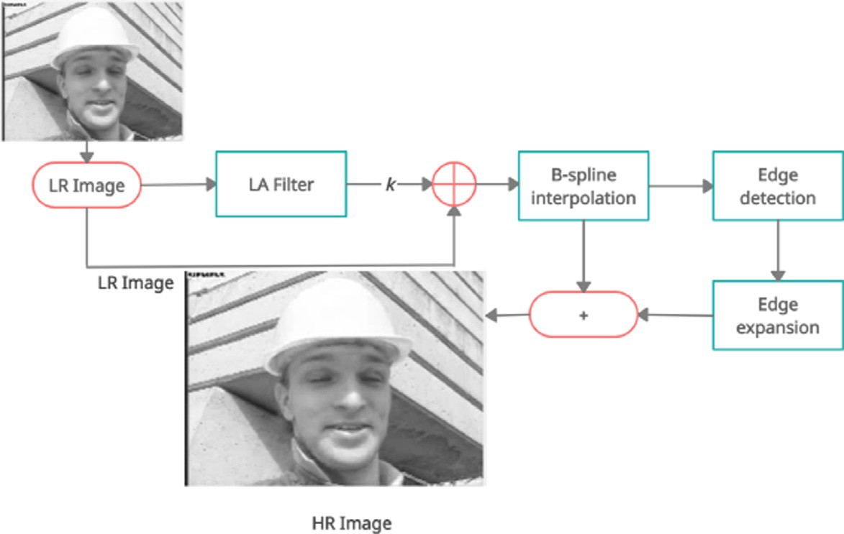

Fig. 2. Block diagram of proposed method.

Fig. 5 depicts HF region (Hair of Face image) restoration at higher upscaling. Fig. 6 shows the edge and texture preservation of an airplane image at 1:4 upscaling. The error image of the Air- plane image and the Lena image are shown in Fig. 7 and 8, respec- tively. Tables 2 and 3 show the PSNR, SSIM, and FSIM parameters of various methods, as well as the OLA e-spline, at 1:4, 1:16 upscal- ing. The peak performance parameters are highlighted. Table 5 shows the execution time of various methods for various image sizes at 1:4 upscaling. Table 4 shows the average PSNR gain of the proposed and other state-of-the-art algorithms at 1:4 upscal- ing. The proposed scheme outperforms the Bilinear, Bicubic, Lanc- zos, and USM interpolated methods by 8.0752, 8.3839, 3.4753, and 9.5355 dB, respectively.

* 1. *Result Analysis*

Face, Baby, and Airplane images are considered for subjective evaluation. Instead of selecting a specific region of the image, such as the low, medium, or high frequency category. Here, the Baby, Airplane, and Face images represent low, medium, and high fre- quencies, respectively, and have been enlarged as shown in Fig. 3, 6, and 4. The Baby falls into the category of a smooth image, as it contains the majority of the low region variance. For this rea- son, it is regarded as a low-frequency image. As shown in Fig. 3, homogeneous regions are completely preserved after enlargement 3 (j).

The hair in the Face image represents the image’s HF or edges. The hair is completely emphasized and distinguishable after enlargement to compensate for the HF loss caused by interpola- tion, as shown in Fig. 4 (j). Similarly, the Airplane image is made up of low, medium, and high-frequency regions, which are fairly enhanced after upscaling. The name of the airplane and its edges are visible after interpolation, as shown in Fig. 6 (j), whereas a smoother interpolated image can be found in (b), (c), and (d). As a result of the subjective analysis, it was concluded that the pro- posed method, when compared to Lanczos interpolation, preserves the loss edge information as well as the minute details after upscaling. However, the restoration of the edge region is depen- dent on the depth of degradation of the edges. When compared to other existing algorithms, the OLA e-spline produces the best results by restoring all missing details.

For subjective evaluation, the Face, Baby, and Airplane images are considered. Instead of selecting a particular region of the image, which may be low, medium, or HF category. Here Baby,

Airplane and Face images represent low, medium, and HF respec- tively, and then enlarged as shown in Fig. 3, Fig. 6, and 4. The Baby is a category of a smooth image, as most of the region variance is very low for this, it considered as a low-frequency image. It can be noticed that homogeneous regions are completely preserved after enlargement as shown in Fig. 3 (j). The Face image’s hair rep- resents HF or edges of the image. After enlargement, the hair is completely emphasized and distinguishable to overcome the HF loss because of interpolation as given in Fig. 4 (j). Similarly, the Air- plane image is a combination of low, medium, and HF regions, and these are enhanced fairly, after upscaling. After interpolation, the name of Airplane and its edges are visible as manifested in Fig. 6

(j) whereas more smoothness interpolated image can be found in (b), (c), and (d). Hence from the subjective analysis, it concluded that the proposed method preserves the loss edge information along with the minute details after upscaling compared to Lanczos interpolation. However, the edge region restoration depends upon the depth of degradation of edges. Compared to other existing algorithms, the OLA e-spline provides the most desirable results by restoring all missing details. The proposed method restoration quality is expressed by the error image. Fig. 7 and 8 depict the error image of Airplane and the Lena image, respectively, at 1 : 4 upscal- ing. More error can be seen at the edge parts of the Airplane image in Fig. 7 (f) and (h). This is due to the fact that edges are not restored in DST and USM. In the case of the Lena image, errors exist in both the low and high-frequency parts of the image, as shown in Fig. 8 (a), (d), and (e). As shown in Fig. 8 (c), the Lanczos interpo- lated image has less error than the existing algorithms. It is also worth noting that the proposed method produces the least amount of error in both cases. According to Tables 2 and 3, the proposed

In the case of the Baby (512 × 512) image, the OLA e-spline out- algorithm performs better objectively for various database images. performs Lanczos with a maximum PSNR gain of 5.9396 dB at a

1 : 4 upscaling ratio. Similarly, the proposed method outperforms the NEDI, Edge error, and USM interpolation methods by 10.2557, 10.6189, and 10.1556 dB, respectively. At 1 : 4 upscaling, the OLA e-spline achieves a PSNR gain of 12.5221 and 4.4841 dB over the Bilinear scheme for HF images like Airplane and Face. The proposed method produces better results in images with low and medium frequency bands, such as Baby and Lena. It produces a visible result because the restoration of HF after interpolation is required. Similarly, the proposed method outperforms other state- of-the-art methods in terms of observable parameters such as PSNR, SSIM, and FSIM at 1 : 16 upscaling schemes, as shown in

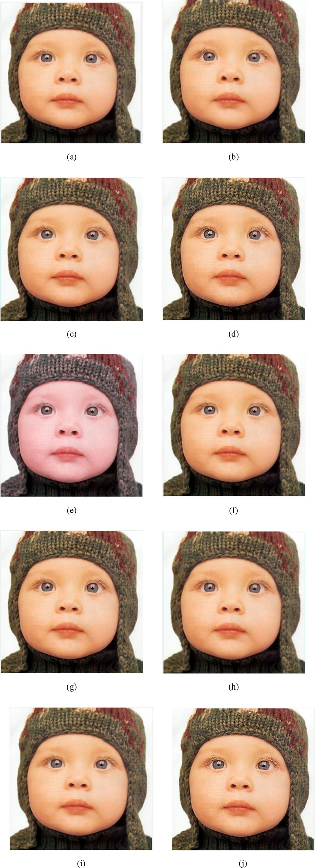 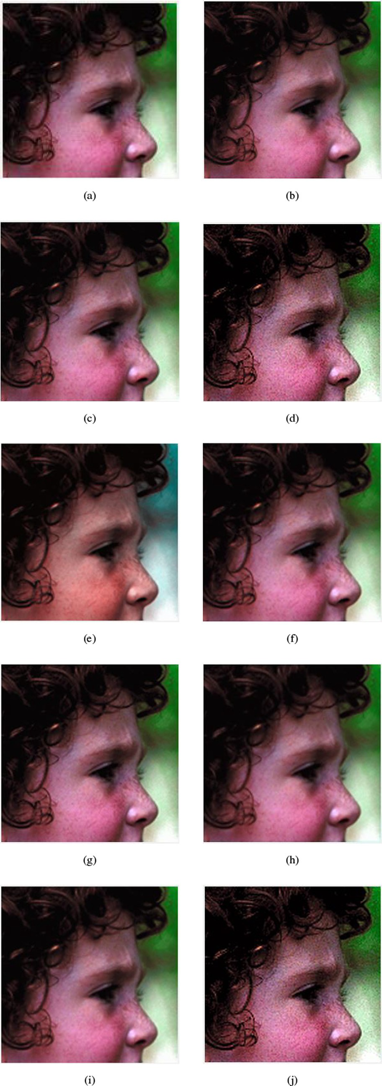

Fig. 3. (a) Baby LR image and results of several upscaling algorithm at 1:4 upscaling by (b) Bilinear [1] (c) Bicubic [2] (d) Lanczos [4] (e) NEDI [5] (f) ICBI [15] (g) DST [9]

(h) Edge error [10] (i) USM (j) Proposed method.

Fig. 4. (a) Face LR image and results of several upscaling algorithm at 1:4 upscaling by (b) Bilinear [1] (c) Bicubic [2] (d) Lanczos [4] (e) NEDI [5] (f) ICBI [15] (g) DST [9]

(h) Edge error [10] (i) USM (j) Proposed method.

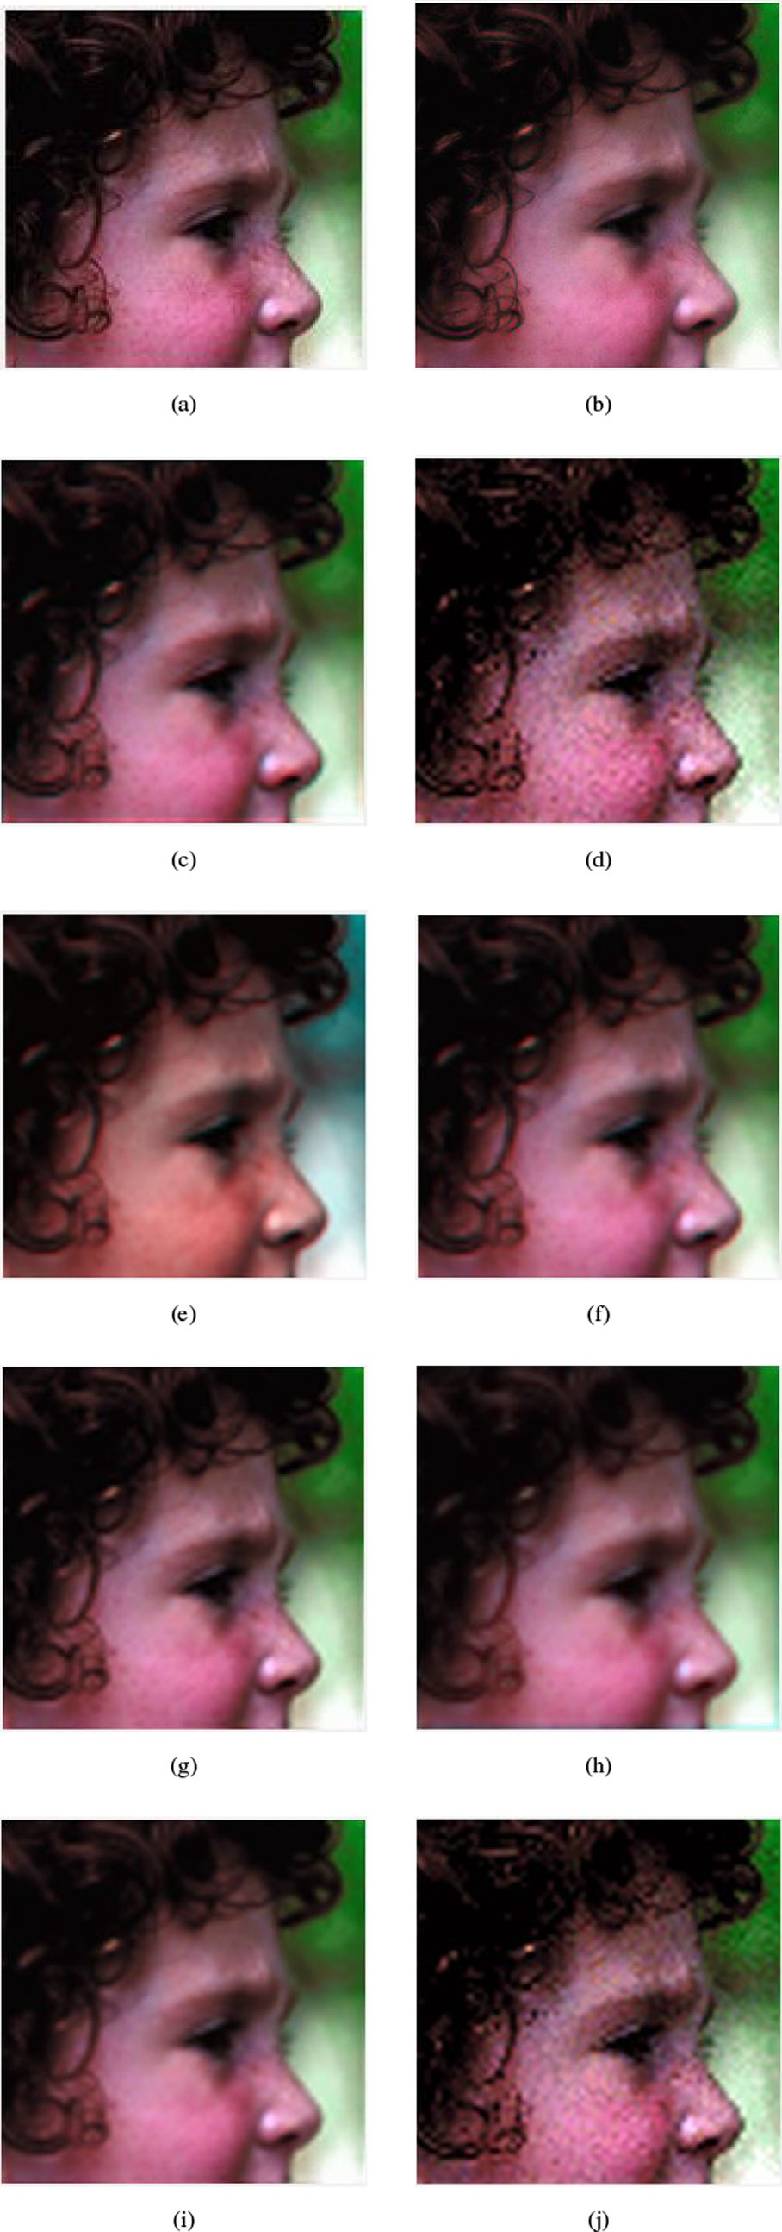 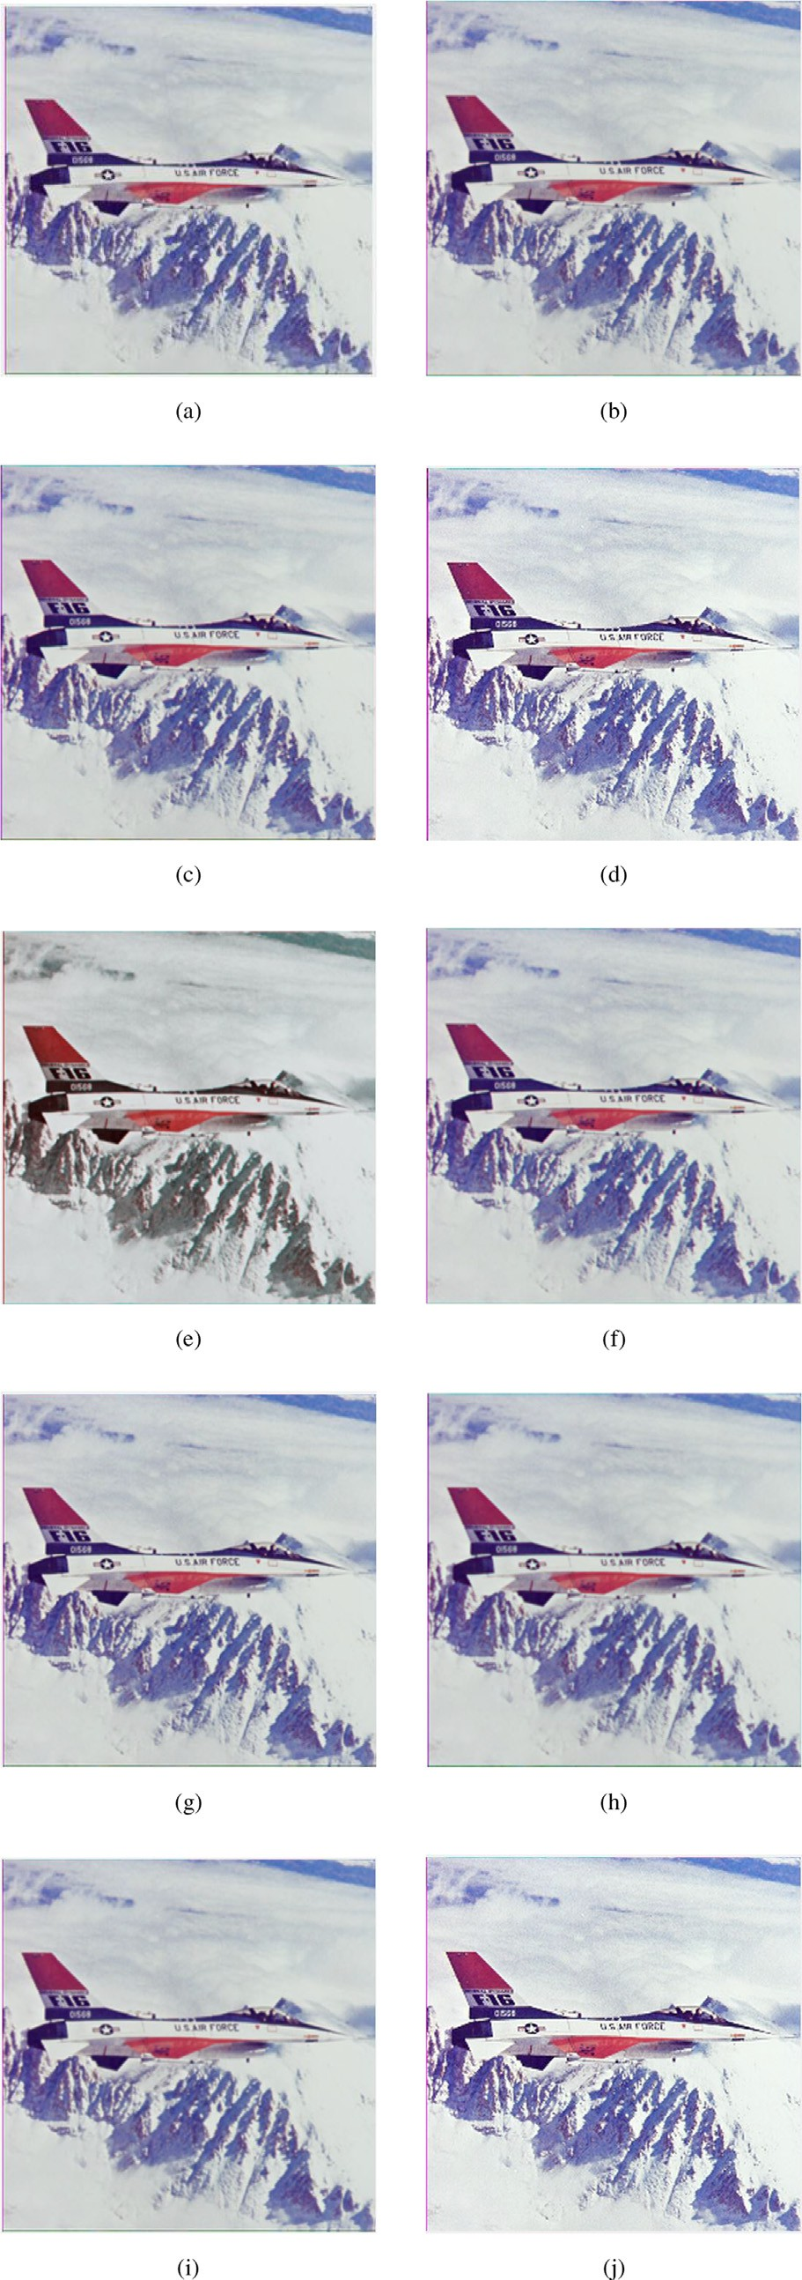

Fig. 5. (a) Face LR image and outcome of different algorithms at 1:16 upscaling by

(b) Bilinear [1] (c) Bicubic [2] (d) Lanczos [4] (e) NEDI [5] (f) ICBI [15] (g) DST [9] (h) Edge error [10] (i) USM (j) Proposed method.

Fig. 6. (a) Airplane LR image and results of several upscaling algorithm at 1:4 upscaling by (b) Bilinear [1] (c) Bicubic [2] (d) Lanczos [4] (e) NEDI [5] (f) ICBI [15]

(g) DST [9] (h) Edge error [10] (i) USM (j) Proposed method.

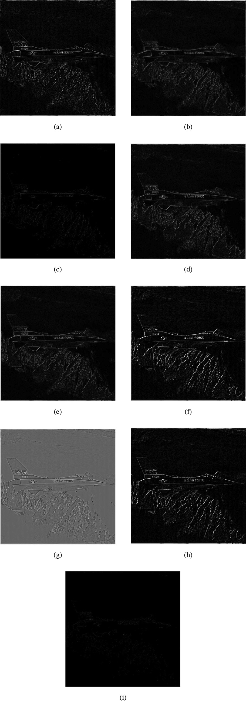 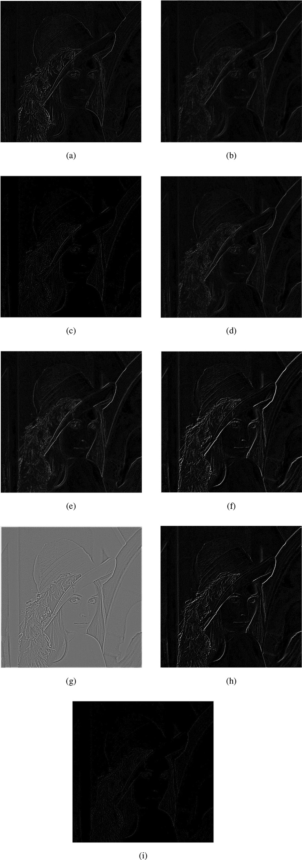

Fig. 7. Airplane error image of several interpolation algorithms at 1:4 upscaling by

(a) Bilinear [1] (b) Bicubic [2] (c) Lanczos [4] (d) NEDI [5] (e) ICBI [15] (f) DST [9] (g) Edge error [10] (h) USM (i) Proposed method.

Fig. 8. Lena error images of several interpolation algorithm at 1:4 upscaling by (a) Bilinear [1] (b) Bicubic [2] (c) Lanczos [4] (d) NEDI [5] (e) ICBI [11] (f) DST [9] (g) Edge error [10] (h) USM (i) Proposed method.

Table 3. As a result, the proposed algorithm produces visible results for any upscaling factor of any type of image.

Traditional methods such as Bilinear, Bicubic, and DST perform interpolation without taking smooth (low frequency) and edge (HF) into account separately. Blur is introduced in nonstationary regions as a result. Furthermore, subjective and objective evalua- tions show that the Lanczos method produces comparable results, but Lanczos interpolation introduces some ringing artifacts in the HR image due to the sinc function. As a result, it will produce poor results when compared to the proposed method. Furthermore, NEDI, and ICBI perform edge interpolation but introduce false edge artifacts in the up-scaled images. In the proposed scheme, the degraded HF of the image is completely stored in the e-spline tech- nique after LA filtering before interpolation and edge expansion after up-sampling. In the USM, the directly HPF version of the LR image is extracted and added to the LR image before up- sampling, resulting in a lower PSNR gain. In addition, the subjec- tive result shows that edge error is superior to USM because it uses the inverse approach to restore the degraded HF. Because the error generated by interpolation is added, this method is capable of restoring the lost edge and fine details due to up-sampling. How- ever, for different scaling-factors, such as 4, its performance is poor, as shown in Table 3. The proposed scheme is significant for using the pre-processing technique before e-spline interpolation; for this, the proposed algorithm produces better results. The USM concept is used for pre-processing. It is used prior to enlargement to restore details lost due to interpolation. As a result, the proposed method is simpler than NEDI, and ICBI. And, if this is implemented in real-time applications, the proposed scheme will be less expen- sive than the NEDI and ICBI without sacrificing output quality. According to the experimental results, the proposed scheme pro- vides a better HR image both objectively and subjectively when compared to other state-of-the-art methods. However, depending on the processing time, it lags behind the Lanczos method. Because the proposed method employs LA filtering, its execution time is longer than that of Lanczos.

The processing time is the most important factor in a real-time application. However, as shown in Table 5, the proposed method takes longer to execute than USM because it uses adaptive filtering to produce the sharpened HR image. Table 5 shows that the com- putational time of the suggested method is longer than that of the Bicubic and Bilinear methods. These methods perform uniform interpolation over the image’s low and high variance regions. On the other hand, this preprocessing technique results in a more natural-looking HR. Furthermore, NEDI, and ICBI take longer to process than other methods because they perform different inter- polation for the image’s edge and texture regions.

Based on the objective and subjective experimental results, the OLA e-spline method outperforms the Bicubic, Lanczos, NEDI, and other algorithms discussed in the literature.

1. Conclusion

An experimental result shows that the proposed scheme out- performs the existing schemes both objectively and subjectively. This is due to pre-processing prior to interpolation, followed by edge expansion. As a result, the smooth regions are completely preserved and the medium frequencies are reasonably enhanced. The HF is more focused, allowing it to recover all lost details. The CS optimization is then used to combine the LA blurred image with the LR images with the optimised gain factor, which is used before upscaling to reduce the zigzag and blur artifacts, and the edge expansion of the interpolated image is performed after upscaling. The OLA e-spline is so simple that it can be used in any display

device that requires a high resolution image. It will reduce the computational burden on real-time applications. This method adaptively recovers the image’s low, medium, and high- frequency regions based on the lost details. According to the results analysis, this elite and sophisticated method performs well for all frequency regions. For scaling factors of 2 and 4, respec- tively, this method achieves a PSNR gain of 3.4753 and 1.0339 dB over the Lanczos interpolation method. The proposed method achieves a PSNR gain of 9.5345 dB over USM and 9.1938 dB over DST for scaling factor 2. HR image edges are more pronounced and distinguishable from smooth regions. The computational com- plexity is extremely low. It can be used in consumer electronics applications for this purpose. This work can be expanded by designing an optimized USM filter or by employing a post- processing approach to reduce artifacts caused by upscaling.

Declaration of Competing Interest

The authors declare that they have no known competing finan- cial interests or personal relationships that could have appeared to influence the work reported in this paper.

References

1. Yan F., Zhao S., Venegas-Andraca S.E. Implementing Bilinear Interpolation on Quantum Images, arXiv preprint arXiv:2010.10254 (2020).
2. [Huang Z, Cao L. Bicubic interpolation and extrapolation iteration method for](http://refhub.elsevier.com/S1110-8665(21)00069-4/h0010) [high resolution digital holographic reconstruction. Opt Lasers Eng](http://refhub.elsevier.com/S1110-8665(21)00069-4/h0010) [2020;130:106090](http://refhub.elsevier.com/S1110-8665(21)00069-4/h0010).
3. [Zachariadis O, Teatini A, Satpute N, Gómez-Luna J, Mutlu O, Elle OJ, Olivares J.](http://refhub.elsevier.com/S1110-8665(21)00069-4/h0015) [Accelerating B-spline interpolation on GPUs: Application to medical image](http://refhub.elsevier.com/S1110-8665(21)00069-4/h0015) [registration. Computer Methods Programs Biomedicine 2020;193:105431](http://refhub.elsevier.com/S1110-8665(21)00069-4/h0015).
4. [He L, Wu H, Zhao X. The application of Lanczos interpolation in video scaling](http://refhub.elsevier.com/S1110-8665(21)00069-4/h0020) [system based on FPGA. In: Twelfth International Conference on Signal](http://refhub.elsevier.com/S1110-8665(21)00069-4/h0020) [Processing Systems, 11719. International Society for Optics and Photonics;](http://refhub.elsevier.com/S1110-8665(21)00069-4/h0020) [2021. p. 117190G](http://refhub.elsevier.com/S1110-8665(21)00069-4/h0020).
5. [Li X, Orchard MT. New edge-directed interpolation. IEEE Trans Image](http://refhub.elsevier.com/S1110-8665(21)00069-4/h0025) [Processing 2001;10(10):1521–7](http://refhub.elsevier.com/S1110-8665(21)00069-4/h0025).
6. [Liu X, Sun J, Yan G, Lu Y, Xue Y, Li G, et al. 32–2: Improvement in Directional](http://refhub.elsevier.com/S1110-8665(21)00069-4/h0030) [Cubic Convolution Image Interpolation. In: SID Symposium Digest of Technical](http://refhub.elsevier.com/S1110-8665(21)00069-4/h0030) [Papers, 51. Wiley Online Library; 2020. p. 455–8](http://refhub.elsevier.com/S1110-8665(21)00069-4/h0030).
7. [Zhang L, Wu X. An edge-guided image interpolation algorithm via directional](http://refhub.elsevier.com/S1110-8665(21)00069-4/h0035) [filtering and data fusion. IEEE Trans Image Processing 2006;15(8):2226–38](http://refhub.elsevier.com/S1110-8665(21)00069-4/h0035).
8. [Sajjad M, Ejaz N, Mehmood I, Baik SW. Digital image super-resolution using](http://refhub.elsevier.com/S1110-8665(21)00069-4/h0040) [adaptive interpolation based on Gaussian function. Multimedia Tools Appl](http://refhub.elsevier.com/S1110-8665(21)00069-4/h0040) [2015;74(20):8961–77](http://refhub.elsevier.com/S1110-8665(21)00069-4/h0040).
9. [Panda J, Meher S. A Novel Approach of Image Interpolation using DST. In: 2019](http://refhub.elsevier.com/S1110-8665(21)00069-4/h0045) [Fifth International Conference on Image Information Processing (ICIIP). IEEE;](http://refhub.elsevier.com/S1110-8665(21)00069-4/h0045) [2019. p. 606–11](http://refhub.elsevier.com/S1110-8665(21)00069-4/h0045).
10. [Panda J, Meher S. An Efficient Image Interpolation Using Edge-error Based](http://refhub.elsevier.com/S1110-8665(21)00069-4/h0050) [Sharpening. In: 2020 IEEE 17th India Council International Conference](http://refhub.elsevier.com/S1110-8665(21)00069-4/h0050) [(INDICON). IEEE; 2020. p. 1–6](http://refhub.elsevier.com/S1110-8665(21)00069-4/h0050).
11. [Giachetti A, Asuni N. Real-time artifact-free image upscaling. IEEE Trans Image](http://refhub.elsevier.com/S1110-8665(21)00069-4/h0055) [Process 2011;20(10):2760–8](http://refhub.elsevier.com/S1110-8665(21)00069-4/h0055).
12. Rukundo O. Normalized Weighting Schemes for Image Interpolation Algorithms, arXiv preprint arXiv:2011.08559 (2020).
13. [Zheng J, Song W, Wu Y, Liu F. Image interpolation with adaptive k-nearest](http://refhub.elsevier.com/S1110-8665(21)00069-4/h0065) [neighbours search and random non-linear regression. IET Image Proc 2020;14](http://refhub.elsevier.com/S1110-8665(21)00069-4/h0065) [(8):1539–48](http://refhub.elsevier.com/S1110-8665(21)00069-4/h0065).
14. [Zhang J. Weighted-encoding-based image interpolation with the nonlocal](http://refhub.elsevier.com/S1110-8665(21)00069-4/h0070) [linear regression model. Appl Opt 2020;59(28):8588–94](http://refhub.elsevier.com/S1110-8665(21)00069-4/h0070).
15. [Byongsu H, Jonghyon J, Cholsu R. An improved multi-directional interpolation](http://refhub.elsevier.com/S1110-8665(21)00069-4/h0075) [for spatial error concealment. Multimedia Tools Appl 2019;78(2):2587–98](http://refhub.elsevier.com/S1110-8665(21)00069-4/h0075).
16. [Khan S, Lee D-H, Khan MA, Siddiqui MF, Zafar RF, Memon KH, Mujtaba G.](http://refhub.elsevier.com/S1110-8665(21)00069-4/h0080) [Image Interpolation via Gradient Correlation-Based Edge Direction Estimation.](http://refhub.elsevier.com/S1110-8665(21)00069-4/h0080) [Scientific Programming 2020;2020](http://refhub.elsevier.com/S1110-8665(21)00069-4/h0080).
17. [Song Q, Xiong R, Liu D, Xiong Z, Wu F, Gao W. Fast image super-resolution via](http://refhub.elsevier.com/S1110-8665(21)00069-4/h0085) [local adaptive gradient field sharpening transform. IEEE Trans Image Process.](http://refhub.elsevier.com/S1110-8665(21)00069-4/h0085) [2018;27(4):1966–80](http://refhub.elsevier.com/S1110-8665(21)00069-4/h0085).
18. [Zhu S, Zeng B, Zeng L, Gabbouj M. Image interpolation based on non-local](http://refhub.elsevier.com/S1110-8665(21)00069-4/h0090) [geometric similarities and directional gradients. IEEE Trans Multimedia](http://refhub.elsevier.com/S1110-8665(21)00069-4/h0090) [2016;18(9):1707–19](http://refhub.elsevier.com/S1110-8665(21)00069-4/h0090).
19. [Zhang K, Tao D, Gao X, Li X, Xiong Z. Learning multiple linear mappings for](http://refhub.elsevier.com/S1110-8665(21)00069-4/h0095) [efficient single image super-resolution. IEEE Trans Image Process 2015;24](http://refhub.elsevier.com/S1110-8665(21)00069-4/h0095) [(3):846–61](http://refhub.elsevier.com/S1110-8665(21)00069-4/h0095).
20. [Nayak R, Balabantaray BK, Patra D. A New Single-Image Super-Resolution](http://refhub.elsevier.com/S1110-8665(21)00069-4/h0100) [Using Efficient Feature Fusion and Patch Similarity in Non-Euclidean Space.](http://refhub.elsevier.com/S1110-8665(21)00069-4/h0100) [Arabian J Sci Eng 2020;45(12):10261–85](http://refhub.elsevier.com/S1110-8665(21)00069-4/h0100).
21. Fang Y., Shi M., Li X., Liu Y. Single image super-resolution based on gradient profile prior and nonlocal self-similarity feature, in: Eleventh International Conference on Digital Image Processing (ICDIP 2019), Vol. 11179, International Society for Optics and Photonics, 2019, p. 111794P.
22. [Xu Y, Li J, Song H, Du L. Single-Image Super-Resolution Using Panchromatic](http://refhub.elsevier.com/S1110-8665(21)00069-4/h0110) [Gradient Prior and Variational Model. Math Problems Eng 2021;2021](http://refhub.elsevier.com/S1110-8665(21)00069-4/h0110).
23. [Khan S, Lee D-H, Khan MA, Gilal AR, Mujtaba G. Efficient edge-based image](http://refhub.elsevier.com/S1110-8665(21)00069-4/h0115) [interpolation method using neighboring slope information. IEEE Access](http://refhub.elsevier.com/S1110-8665(21)00069-4/h0115) [2019;7:133539–48](http://refhub.elsevier.com/S1110-8665(21)00069-4/h0115).
24. [Yao X, Wu Q, Zhang P, Bao F. Adaptive rational fractal interpolation function](http://refhub.elsevier.com/S1110-8665(21)00069-4/h0120) [for image super-resolution via local fractal analysis. Image Vis Comput](http://refhub.elsevier.com/S1110-8665(21)00069-4/h0120) [2019;82:39–49](http://refhub.elsevier.com/S1110-8665(21)00069-4/h0120).
25. [Liu X, Zhao D, Zhou J, Gao W, Sun H. Image interpolation via graph-based](http://refhub.elsevier.com/S1110-8665(21)00069-4/h0125) [Bayesian label propagation. IEEE Trans Image Process 2013;23(3):1084–96](http://refhub.elsevier.com/S1110-8665(21)00069-4/h0125).
26. [Dougherty ER. Digital image processing methods. CRC Press; 2020](http://refhub.elsevier.com/S1110-8665(21)00069-4/h0130).
27. [Kumar DP. Particle Swarm Optimization: The Foundation. In: Applying Particle](http://refhub.elsevier.com/S1110-8665(21)00069-4/h0135) [Swarm Optimization. Springer; 2021. p. 97–110](http://refhub.elsevier.com/S1110-8665(21)00069-4/h0135).
28. [Ali W, Khan MS, Hasan M, Khan ME, Qyyum MA, Qamar MO, Lee M.](http://refhub.elsevier.com/S1110-8665(21)00069-4/h0140) [Introduction to Cuckoo Search and Its Paradigms: A Bibliographic Survey and](http://refhub.elsevier.com/S1110-8665(21)00069-4/h0140)

[Recommendations. AI and Machine Learning Paradigms for Health Monitoring](http://refhub.elsevier.com/S1110-8665(21)00069-4/h0140) [System: Intelligent Data Analytics 2021;86:79](http://refhub.elsevier.com/S1110-8665(21)00069-4/h0140).

1. [Soumaya Z, Taoufiq BD, Benayad N, Yunus K, Abdelkrim A. The detection of](http://refhub.elsevier.com/S1110-8665(21)00069-4/h0145) [Parkinson disease using the genetic algorithm and SVM classifier. Appl Acoust](http://refhub.elsevier.com/S1110-8665(21)00069-4/h0145) [2021;171:107528](http://refhub.elsevier.com/S1110-8665(21)00069-4/h0145).
2. [Singh H, Kommuri SVR, Kumar A, Bajaj V. A new technique for guided filter](http://refhub.elsevier.com/S1110-8665(21)00069-4/h0150) [based image denoising using modified cuckoo search optimization. Expert Syst](http://refhub.elsevier.com/S1110-8665(21)00069-4/h0150) [Appl 2021;176:114884](http://refhub.elsevier.com/S1110-8665(21)00069-4/h0150).
3. [Parsopoulos MRKE, Martí P, Panos P. Particle Swarm Methods. 2018](http://refhub.elsevier.com/S1110-8665(21)00069-4/h0155).
4. [Kundu R, Chakrabarti A, Lenka P. A Novel Technique for Image Denoising using](http://refhub.elsevier.com/S1110-8665(21)00069-4/h0160) [Non-local Means and Genetic Algorithm. National Academy Science Letters](http://refhub.elsevier.com/S1110-8665(21)00069-4/h0160) [2021:1–7](http://refhub.elsevier.com/S1110-8665(21)00069-4/h0160).
5. [Nair RR, Singh T. MAMIF: multimodal adaptive medical image fusion based on](http://refhub.elsevier.com/S1110-8665(21)00069-4/h0165) [B-spline registration and non-subsampled shearlet transform. Multimedia](http://refhub.elsevier.com/S1110-8665(21)00069-4/h0165) [Tools Appl 2021:1–27](http://refhub.elsevier.com/S1110-8665(21)00069-4/h0165).
6. [Bizzarri M, Lávicˇka M. Interpolation of Hermite data by clamped Minkowski](http://refhub.elsevier.com/S1110-8665(21)00069-4/h0170) [Pythagorean hodograph B-spline curves. J Comput Appl Math 2021;392:113469](http://refhub.elsevier.com/S1110-8665(21)00069-4/h0170).
7. [Zhang W, Zhao Y. Hierarchical Registration of Brain Images Based on B-splines](http://refhub.elsevier.com/S1110-8665(21)00069-4/h0175) [and Laplacian Commutators. Optik 2021:167022](http://refhub.elsevier.com/S1110-8665(21)00069-4/h0175).
8. [Wang Z, Bovik AC, Sheikh HR, Simoncelli EP. Image quality assessment: from](http://refhub.elsevier.com/S1110-8665(21)00069-4/h0180) [error visibility to structural similarity. IEEE Trans Image Process 2004;13](http://refhub.elsevier.com/S1110-8665(21)00069-4/h0180) [(4):600–12](http://refhub.elsevier.com/S1110-8665(21)00069-4/h0180).